OOAD CSA1103 GIRIJA B, 192311044

Question 3: Online Shopping System – Sequence Diagram Scenario: An online shopping application allows customers to browse products, add items to a cart, place orders, and make online payments. After successful payment, inventory is updated automatically and an order confirmation email is sent. If payment fails, the customer is prompted to retry. Warehouse staff process confirmed orders for shipping. Customers can track their order status. The payment gateway validates transactions securely. Discounts are applied automatically during checkout. Customer support handles order cancellation requests. The company wants to understand the interaction between system objects during purchase.
1. Use Case Diagram
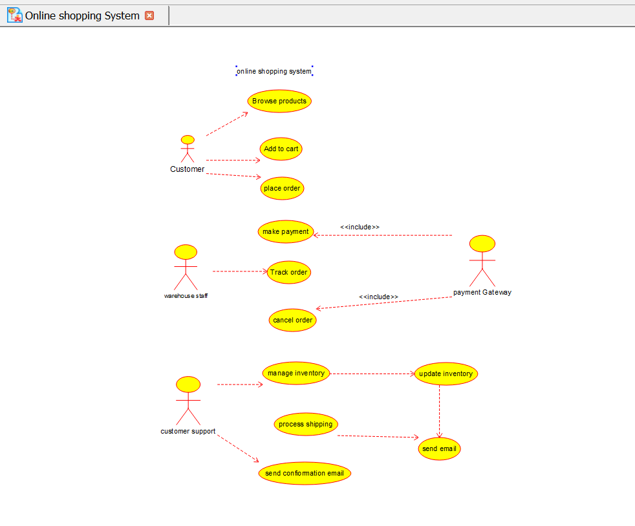

2. Class Diagram
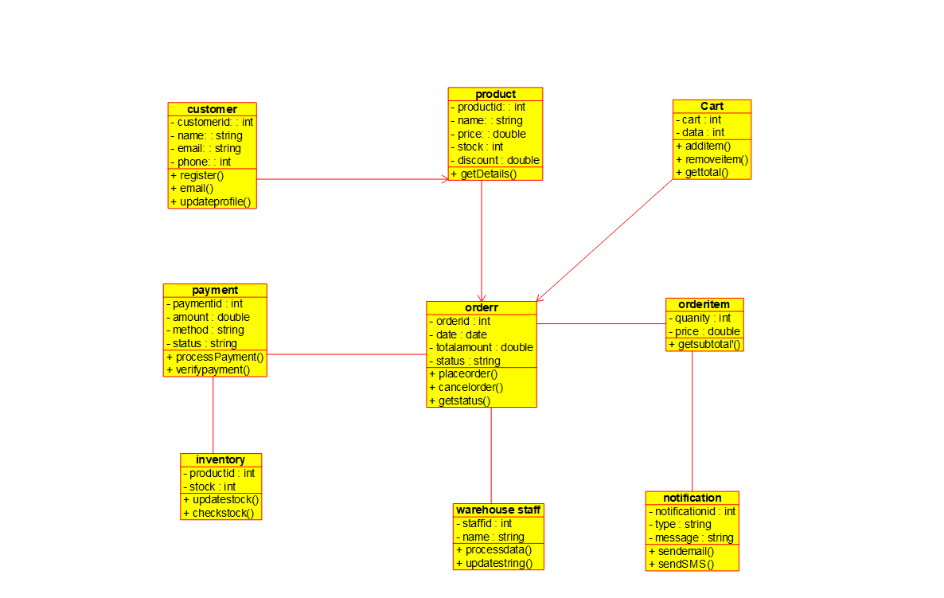
3. Sequence Diagram
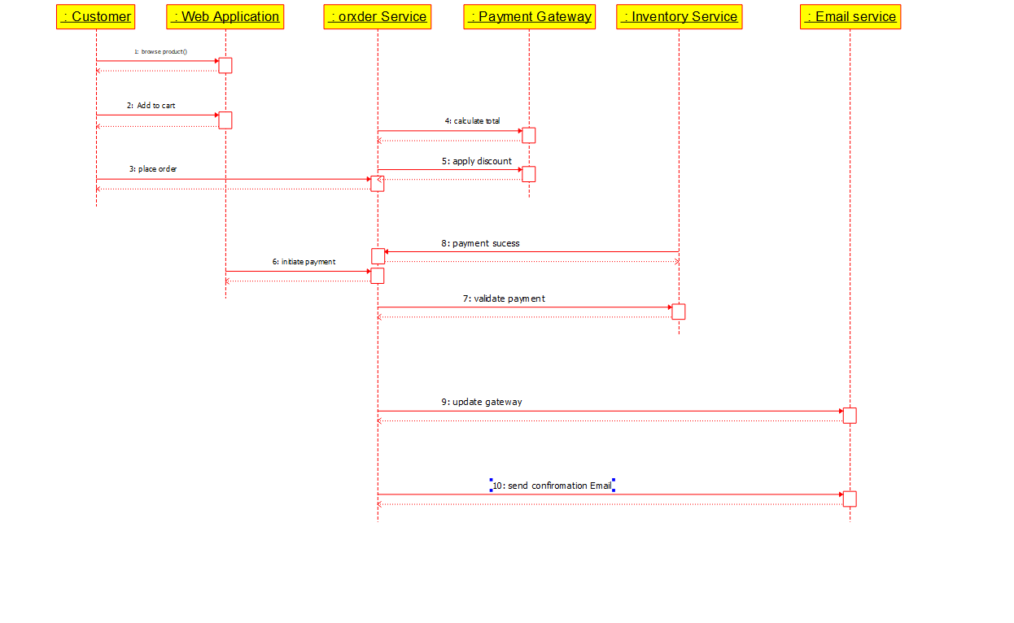4. Activity Diagram
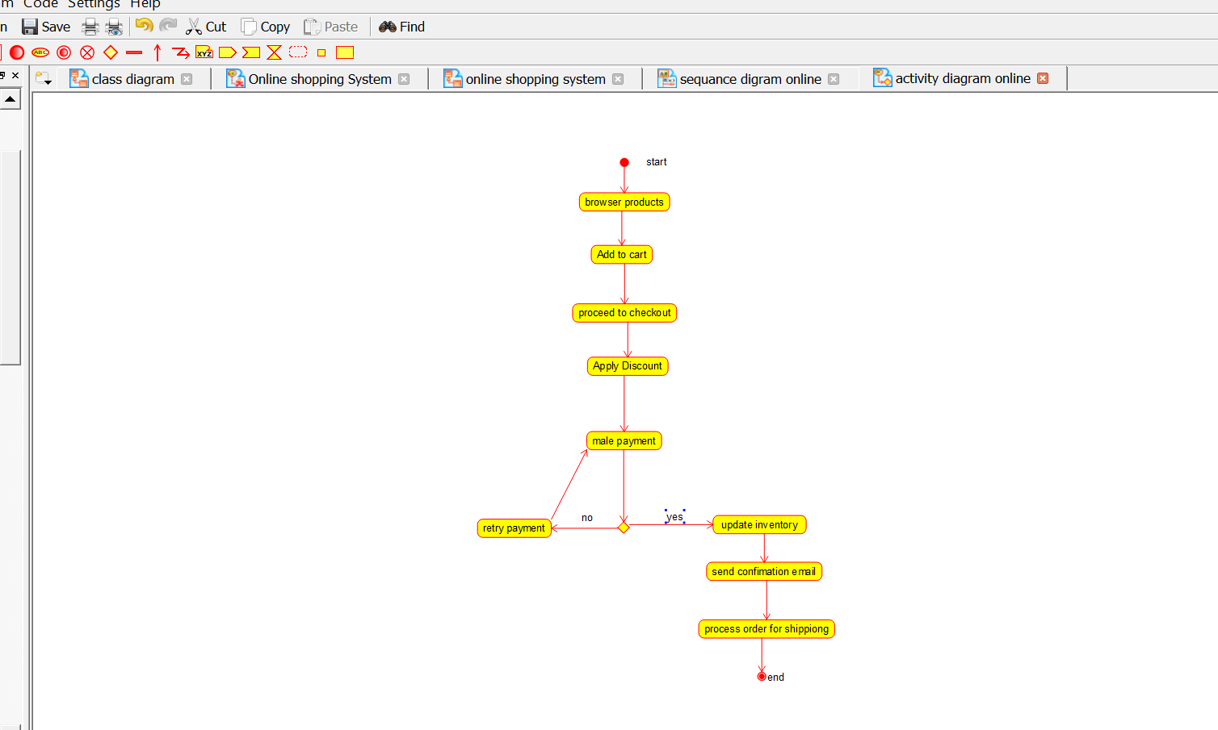
5. Communication Diagram
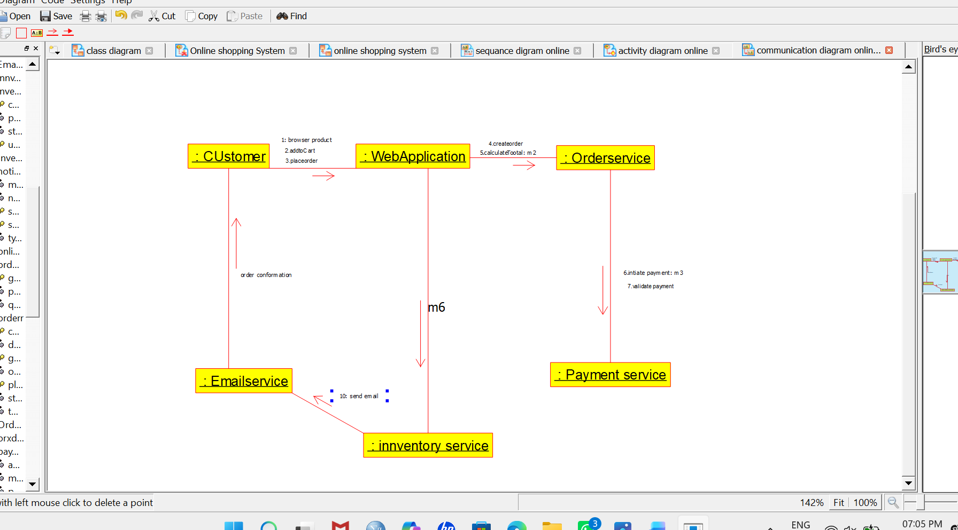
6. State Machine Diagram
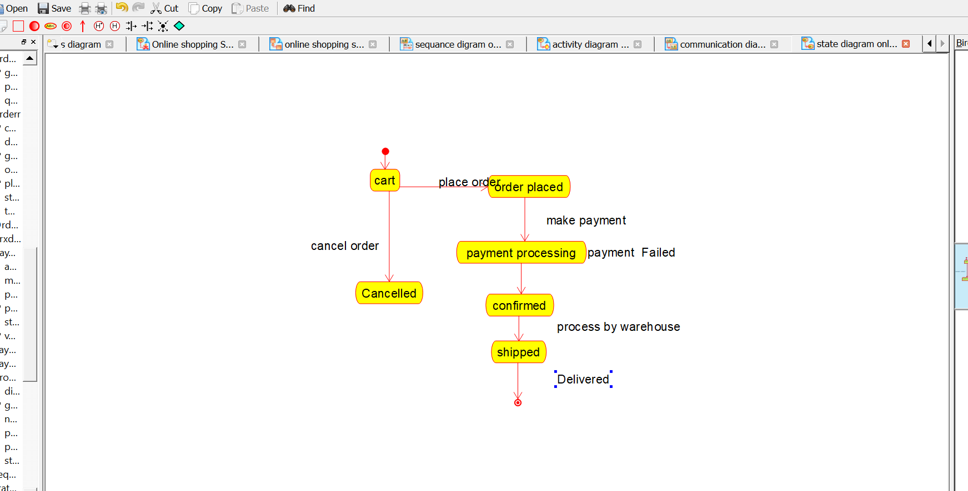

7. Deployment Diagram
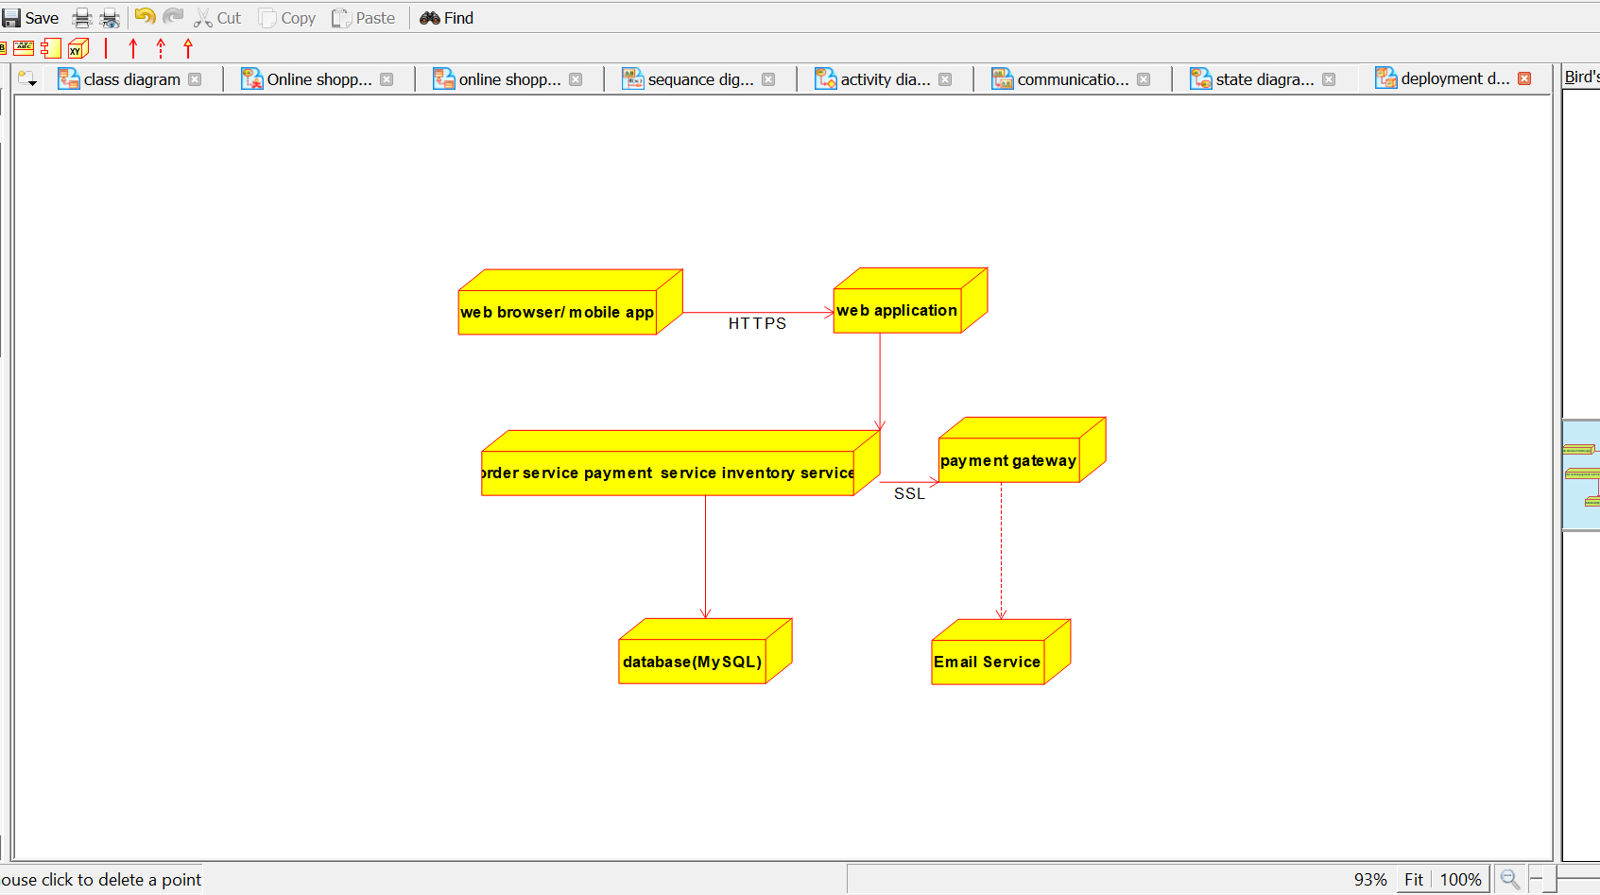
8. Component Diagram
